|  |  |
| --- | --- |
| TEAM ID | PND2022TMID40581 |
| PROJECT TITLE | CLASSIFICATION OF ARRYTHMIA BY USING DEEP LEARNING 2-D ECG SPECTRAL IMAGE REPRESENTATION |

**Configure Image Data Generator Class**

There are five main types of data augmentation techniques for image data, specifically:

1. Image shifts via the width shift_range and height_shift_range arguments.
2. Image flips via the horizontal_flip and vertical_flip arguments.
3. Image rotates via the rotation_range argument.
4. Image brightness via the brightness_range argument.
5. Image zooms via the zoom_range argument.

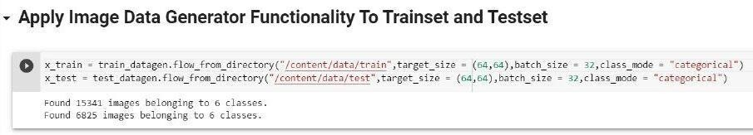

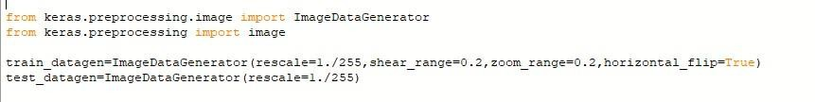

An instance of the ImageDataGenerator class can be constructed for train and test.